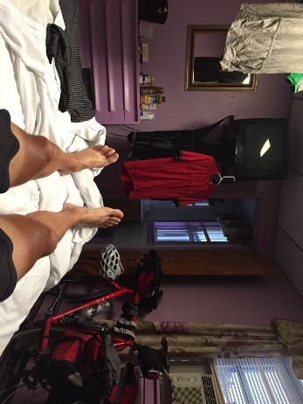
Hans Schabus, Potatocity, 2015, © bildrecht gmbh

Hans Schabus. The Long Road from Tall Trees to Tall Houses
20 February – 24 April 2016
(Main Hall)

Fr, 19 February 2016, 7 pm
León Krempel (Director Kunsthalle Darmstadt) in discussion with Hans Schabus
8 pm Opening of the exhibition

For two decades, Vienna-based sculptor Hans Schabus has been making artworks that self-reflectively play with his experiences of the cosmos. His own surroundings are often the key reference with which he builds ideas into physical manifestation. In a quasi-journalistic manner, this new exhibition itself emerges from the artist’s recent reflective and poetic excursion through space and time. Last summer, Hans Schabus journeyed across the United States on his bicycle. Each day, at high noon, he stopped to document his whereabouts and later sent a postcard home from his overnight stay. This daily ritual informs the sculptural installation in the exhibition.
This exhibition tours to Kunsthalle Darmstadt in 2017. A new artist book accompanies the exhibition. This exhibition was made possible through the generous support of Phileas.
Hans Schabus, born 1970 in Watschig, Carinthia, lives and works in Vienna

